Touch Buzzer

Introduction

Darlington transistor pair is not the best way to drive a buzzer because the transistors are not saturated. However, the advantage of the Darlington pair is that you do not need a PNP transistor. When you order general-purpose BJT transistors online they are usually sold in a pack of 100. Thus you will need two packs if you are using PNP transistors.

There is another Instructable where three transistors were used, including a PNP BJT transistor. However, you can implement the same Instructable with just two transistors.

https://www.instructables.com/id/Touch-Buzzer/

This circuit can also be implemented with a MOSFET. However, MOSFETs might cost more money and are harder to test if there is an issue with a circuit.

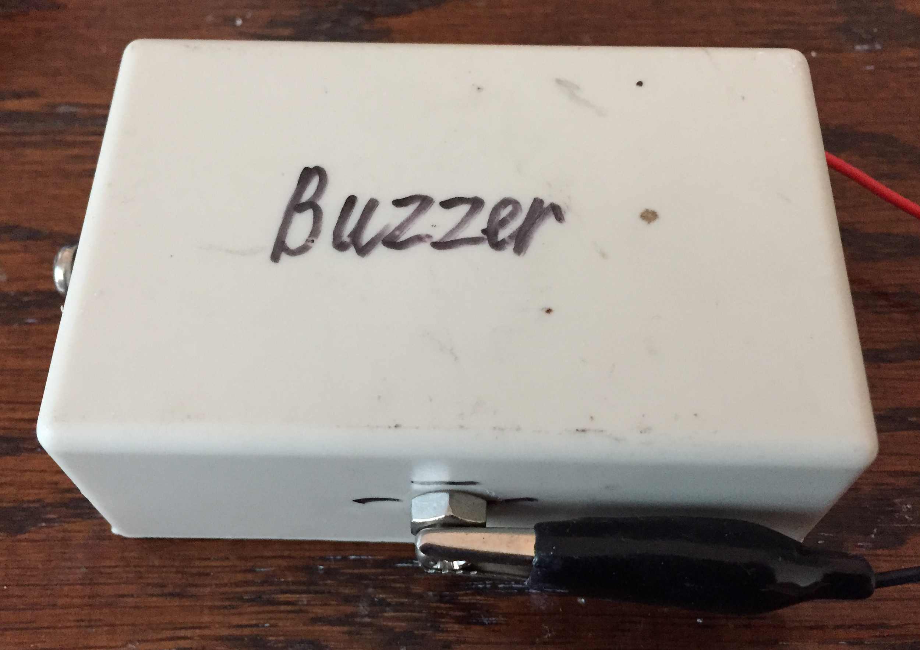
Figure 1: Device.

Tools and Items
Components: Buzzer, 10 ohm resistor, 10 kohm resistor, 100 kohm resistor, 5 NPN general-purpose transistors, general purpose diode, matrix board, wires, box (cardboard or plastic).
Tools: Wire stripper.
Optional tools: multi-meter, voltmeter, soldering iron, solder, blue tag.

3. Step 1: Design the Circuit
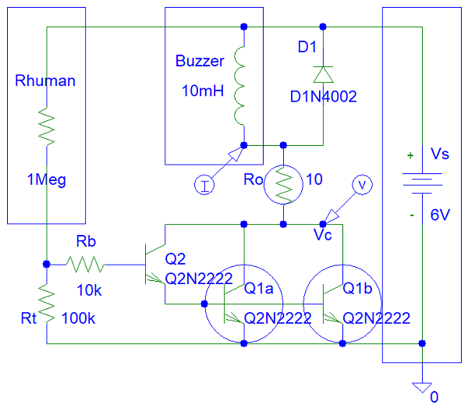
Figure 2: PSpice Drawing.

Total power dissipation across the two Q1 transistors is:

Pt = Ibuzzer * (Vbe1 + Vce2sat) = Ibuzzer * (0.7 V + 0.2 V)

This means half the total power (Pt) for each transistor because the current splits in two when it enters the two transistors and very small current enters the Q2 NPN transistor collector.

Using multiple resistors in parallel reduced the power dissipation across each resistor because there could be high current coming out of the buzzer. You are supposed to use just one 10 ohm resistor because this is a cheap circuits Instructables account. I did not have such a resistor in stock. Thus I used four resistors.

The total resistance of the four resistors parallel is equal to:

Rt = 1 / (1/R1 + 1/R2 + 1/R3 + 1/R4)

You do not need to solder the components. You can just twist the wires.

Step 2: Build the Circuit

You can see the circuit that I made in the box.

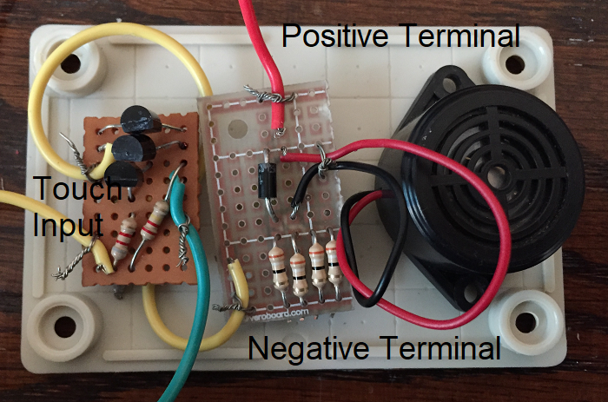
Figure 3: Build the circuit.

